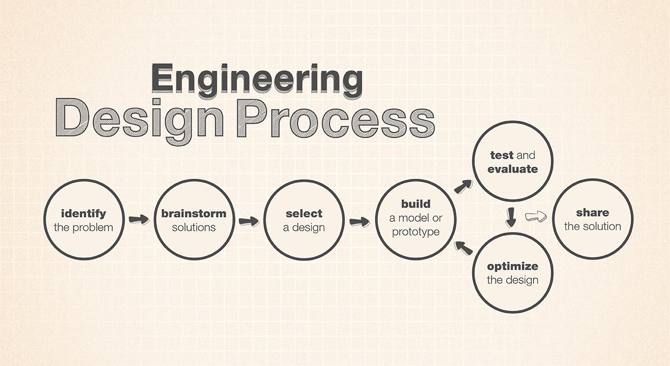
Engineering and Design: Rockets

Name:
Team Members (2):

Engineering Problem (Define an engineering problem that could be solved with a product or process. Use your science knowledge to state challenges in making the solution.)

Background Information (Why is this problem and the solution important?)

Criteria and Constraints:
- Criteria: State how your solution will be successful. For example,
  - Ex. My rocket will return a Lego person safely after a launch.

- Constraints: State the limitations of your solutions. For example,
  - Ex. My rocket must fit a 5mm diameter engine.
Safety Precaution Section (Discuss the safety concerns of your experiment. You cannot leave this section blank.)



Prototype 1
Materials: | Instructions:
Drawing:

Prototype 2
Materials: | Instructions:
Drawing:

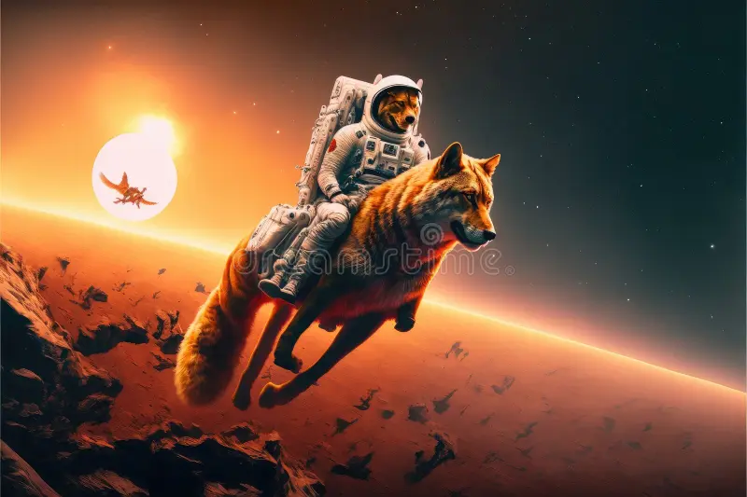
Data
Describe the results of your prototype tests by showing tables,
graphs and charts of your collected data. You must have at least one
data table, one graph and one model for your two prototypes. Make sure you have titles on your tables and graphs.

Table 1: (Add Title Here)

Rocket | Max Height (m) | Flight Time (s) | Payload Safe? (Y/N)
Prototype 1
Prototype 2

Graph 1: (Add Title Here)

Reflections on Success of Project (Did you meet the criteria of your project? Why or why not?)
Directions: Use evidence to fully support the success or failure of each prototype.

Prototype #1 Reflection of Success
Criteria | Successes | Challenges | Improvements
Maximum height
Flight time
Payload

Prototype #2 Reflection of Success
Criteria | Successes | Challenges | Improvements
Maximum height
Flight time
Payload

Assessment Rubric (Covering NGSS Standards: MS-ETS 1-1, MS-ETS 1-2 and MS-ETS 1-3)
Science and Engineering Skill | SEP Subskill | Beginning | Progressing | Approaching | Meeting
S.S1 Ask Questions and Define Problems | S.S1.1b Students can identify a problem and develop testable questions based on the observations. | In engineering, my problem is missing or unrelated with criteria and constraints absent. | In engineering, I can state a problem that may or may not be solved with a product or process including unrelated or missing criteria and constraints. | In engineering, I can describe a problem that could be solved with a product or process including at least one criteria for success and one constraints. | In engineering, I can correctly describe a problem that could be solved with a product or process including multiple criteria for success and constraints.

Science and Engineering Skill | SEP Subskill | Beginning | Progressing | Approaching | Meeting
S.S3 Plan and Carry out Investigations OR Design Challenge | S.S3.3a Students can design a product, system or process to meet a need or solve a problem | I designed a system unrelated to problem or my system was incomplete | I successfully designed a 2 dimensional system to meet a need or solve a problem | I designed a system that met some needs or partially solved a problem. | I successfully designed a 3 dimensional system that met a need or solve a problem.

Science and Engineering Skill | SEP Subskill | Beginning | Progressing | Approaching | Meeting
S.S5 Communicate and Defend a Conclusion/ Solution Based on Evidence | S.S5.5a Make and defend a claim or design/redesign solution based on evidence. | I can state a claim unrelated to the design or my claim is missing. | I can make and defend a claim or design solution without evidence. | I can make and defend a claim using unrelated or illogical evidence. | I can use evidence to make and defend a logical claim or design solution.
 | S.S5.5c Evaluate competing arguments and design solutions based on evidence | I can state the different arguments or design solutions. | I can compare different arguments or design solutions. | I can use evidence to evaluate different arguments or design solutions. | I can use evidence accurately to evaluate different arguments or design solutions.

